SIMATS ENGINEERING
ASSESSMENT TOOL 2: Logic Reasoning & Mapping Exercise
COURSE NAME: ARTIFICIAL INTELLIGENCE AND EXPERT SYSTEMS
COURSE OUTCOME COVERED
COURSE CODE: MLA01
CO3: Implement propositional and first-order logic using resolution, unification, and inference techniques for knowledge representation and reasoning.(BTL 3) Assessment Tool Weightage: 15%
Total Marks: 100 Time: 60 Mins No. of Questions: 5
Annexure A
Logic Reasoning & Mapping Exercise
Code of Conduct:
I ____________________ (Name / Reg No) certify that this submission is my original work and that I have adhered to the guidelines specified for this assessment. I understand that any violation of academic integrity rules will result in disciplinary action.

Signature of the student:

Criterion | Weightage | Marks Obtained
1. Problem Analysis and Knowledge Identification | 15%
2. Logical Representation and Mapping | 20%
3. Predicates, Variables, Constants and Quantifiers | 15%
4. Logical Connectives and Formula Construction | 10%
5. Inference and Logical Reasoning | 15%
6. Unification and Substitution | 10%
7. Resolution and Proof Construction | 10%
8. Mapping Diagram / Clarity and Presentation | 5%
Total | 100%
ANSWER ANY ONE OF THE FOLLOWING
 | Q.No Use Case Scenario
1 | Smart HealthcareDiagnosis | A hospital uses an AI system to identify possible diseases frompatient symptoms. Ravi has fever, cough, and body pain. Patientswith fever and cough may have flu. Patients with flu and body painmay have viral infection. Patients with viral infection requiremedical attention.  Tasks:  (i) Identify facts, entities, predicates, variables, and constants. (ii) Represent the knowledge using Propositional Logic. (iii) Represent the knowledge using FOL with suitable quantifiers. (iv) Perform unification for two relevant predicates. (v) Apply resolution to prove whether Ravi has a viral infection. (vi) Show the complete inference sequence and final conclusion.
2 | Student AcademicAdvising | A university AI system recommends academic support based onattendance and examination performance. Priya has attendancebelow 75% and has failed two courses. Students with low attendancerequire attendance counseling. Students who fail two or morecourses require academic counseling. Students requiring both typesof counseling need academic support.  Tasks:  (i) Identify the knowledge components.  (ii) Convert the statements into Propositional Logic. (iii) Develop FOL representations using predicates and quantifiers. (iv) Identify suitable substitutions and perform unification. (v) Use resolution to prove whether Priya requires academic support.(vi) Explain the reasoning steps leading to the conclusion.
3 | Intelligent LoanApproval | A bank wants to use an AI knowledge-based system for preliminaryloan approval. Arun has stable employment, sufficient income, ahigh credit score, and good repayment history. Customers withstable employment and sufficient income qualify for preliminaryapproval. Customers with a high credit score and preliminaryapproval are classified as low-risk. Low-risk customers with goodrepayment history can be recommended for loan approval.  Tasks:  (i) Identify entities, facts, predicates, and rules.  (ii) Map the scenario into Propositional Logic.  (iii) Represent the rules using FOL.

(iv) Demonstrate unification and substitution.
(v) Use resolution to prove or disprove LoanApproved(Arun). (vi) Provide the final inference with justification.
4 | Vehicle Fault Diagnosis | An automobile service center uses an expert system to diagnosevehicle faults. Car101 does not start and its headlights are dim.Vehicles that do not start and have dim headlights may have abattery problem. Vehicles with a battery problem require batteryinspection. Vehicles requiring battery inspection are marked forservice.  Tasks:  (i) Extract the facts and rules from the scenario.  (ii) Represent them using Propositional Logic.  (iii) Develop suitable FOL predicates and rules.  (iv) Perform unification for the vehicle-related predicates. (v) Apply resolution to determine whether Car101 has a batteryproblem. (vi) Derive whether Car101 should be marked for serviceand explain the inference.
5 | Cybersecurity  Threat Detection | An organization uses an AI system to identify cyber threats. User101has five failed login attempts and logged in from an unusuallocation. Multiple failed login attempts indicate a possiblebrute-force attack. A brute-force attack combined with an unusuallogin location indicates suspicious activity. Suspicious activitycombined with unauthorized access to confidential files indicates apossible security breach.  Tasks:  (i) Identify the facts, entities, predicates, and rules.  (ii) Map the knowledge into Propositional Logic.  (iii) Represent the rules using FOL.  (iv) Demonstrate unification and substitution.  (v) Apply resolution to determine whether User101 is involved in apossible security breach.  (vi) Present the complete reasoning chain and final inference.

EVALUATION RUBRICS:
Criterion | Weightage (%) | Excellent | Good | Average | Poor
Problem  Understanding & KnowledgeIdentification | 15% | 13–15% –Clearly  identifies  entities, facts, relationships, assumptions, and reasoningrequirements from the givenscenario. | 10–12% – Identifies  most  relevant  knowledge with minor omissions. | 7–9% – Identifies basic knowledge but misses several important  elements. | 0–6% – Poor orincorrect  identification ofthe givenknowledge.
Logical  Representation & Mapping | 20% | 17–20% –Accurately  maps  real-world  statements intoappropriate  propositional and first-orderlogic  representations. | 13–16% – Provides  mostly  correct  logical  mappings  with minor errors. | 9–12% – Provides partial mappings withseveral logical errors. | 0–8% – Logicalmapping islargely incorrector missing.
Predicates,  Variables,  Constants &Quantifiers | 15% | 13–15% –Correctly  identifies andapplies  predicates,  variables,  constants,  universal andexistential  quantifiers. | 10–12% – Uses the concepts  correctly  with minor errors. | 7–9% – Demonstrates partial  understanding with some incorrect  usage. | 0–6% – Conceptsare incorrectlyapplied ormissing.
Logical  Connectives &Formula  Construction | 10% | 9–10% –Correctly  applies AND, OR, NOT, implication,  and  equivalence to | 7–8% – Mostly  correct use of  connectives with minor errors. | 5–6% – Basicuse of connectives but several errors occur. | 0–4% – Incorrector incompleteformula  construction.

construct validlogical
formulas.
Inference &Logical  Reasoning | 15% | 13–15% –Performs  accurate  step-by-step  reasoning andderives validconclusions  from the givenknowledge. | 10–12% – Reasoning is mostly  correct withminor gaps. | 7–9% – Provides partial reasoning withsome incorrect conclusions. | 0–6% –Reasoning isincorrect,  unsupported, ormissing.
Unification &Substitution | 10% | 9–10% –Correctly  identifies  substitutions and MostGeneral Unifier(MGU) andapplies themaccurately. | 7–8% – Correctly  performs  most  unification  steps with  minor errors. | 5–6% – Demonstrates basic  understanding but has several errors. | 0–4% – Unableto performunification  correctly.
Resolution / Proof  Construction | 10% | 9–10% –Correctly  applies  resolution andpresents a clear, logically validproof of thequery. | 7–8% – Resolution is mostly  correct with  minor errors. | 5–6% – Shows partial  understanding but proof contains gaps. | 0–4% –Resolution isincorrect or notdemonstrated.
Clarity,  Mapping  Diagram &Presentation | 5% | 5% – Providesa clear, well-organized  mapping/logic diagram withaccurate  notation andexcellent  presentation. | 4% – Presentation is clear with minor  formatting or  diagram  issues. | 3% – Basicpresentation with limitedclarity. | 0–2% – Poorlyorganized,  unclear, or  incomplete  presentation.

1 Smart Healthcare Diagnosis

A hospital uses an AI system to identify possible diseases from

patient symptoms. Ravi has fever, cough, and body pain. Patients

with fever and cough may have flu. Patients with flu and body pain

may have viral infection. Patients with viral infection require

medical attention.

Tasks:

(i) Identify facts, entities, predicates, variables, and constants.

(ii) Represent the knowledge using Propositional Logic.

(iii) Represent the knowledge using FOL with suitable quantifiers.

(iv) Perform unification for two relevant predicates.

(v) Apply resolution to prove whether Ravi has a viral infection.

(vi) Show the complete inference sequence and final conclusion.

ANSWER:

1. Problem Understanding & Knowledge Identification

Scenario Analysis
The hospital uses an AI-based expert system to infer a possible disease from observed patient symptoms.
Patient: Ravi

Facts
- Ravi has fever.
- Ravi has cough.
- Ravi has body pain.

Knowledge Rules
- If a patient has fever AND cough, the patient may have flu.
- If a patient has flu AND body pain, the patient may have viral infection.
- If a patient has viral infection, the patient requires medical attention.

Entities
Entity | Description
Ravi | Patient
Fever | Symptom
Cough | Symptom
Body pain | Symptom
Flu | Possible disease
Viral infection | Possible disease
Medical attention | Required action

Relationships
Fever(Ravi)∧Cough(Ravi)→Flu(Ravi) Flu(Ravi)∧BodyPain(Ravi)→ViralInfection(Ravi) ViralInfection(Ravi)→MedicalAttention(Ravi)

Reasoning Requirement
The objective is to determine whether:
ViralInfection(Ravi)​
can be logically inferred from the available facts and rules.

Assumption
For this logic exercise, the words "may have" are represented as an implication rule. This is a logical inference exercise, not a real-world medical diagnosis.

2. Logical Representation & Mapping

A. Propositional Logic
Define:
- F: Ravi has fever
- C: Ravi has cough
- B: Ravi has body pain
- L: Ravi has flu
- V: Ravi has viral infection
- M: Ravi requires medical attention

Facts
F C B

Rules
Rule 1:
(F∧C)→L
Rule 2:
(L∧B)→V
Rule 3:
V→M

Knowledge Base
KB={F,C,B,(F∧C)→L,(L∧B)→V,V→M}

B. First-Order Logic
Define the predicates:
Fever(x) Cough(x) BodyPain(x) Flu(x) ViralInfection(x) MedicalAttention(x)

Facts
Fever(Ravi) Cough(Ravi) BodyPain(Ravi)

Rule 1
∀x[(Fever(x)∧Cough(x))→Flu(x)]

Rule 2
∀x[(Flu(x)∧BodyPain(x))→ViralInfection(x)]

Rule 3
∀x[ViralInfection(x)→MedicalAttention(x)]

3. Predicates, Variables, Constants & Quantifiers

Predicates
Predicate | Meaning
Fever(x) | x has fever
Cough(x) | x has cough
BodyPain(x) | x has body pain
Flu(x) | x has flu
ViralInfection(x) | x has viral infection
MedicalAttention(x) | x requires medical attention

Variable
x
represents any patient.

Constant
Ravi
represents the specific patient.

Universal Quantifier
∀x
means for every patient x.
Example:
∀x[(Fever(x)∧Cough(x))→Flu(x)]

Existential Quantifier
Although it is not required to derive the answer, an existential statement can represent the existence of a patient with the symptoms:
∃x[Fever(x)∧Cough(x)∧BodyPain(x)]
This means:
There exists at least one patient who has fever, cough, and body pain.

4. Logical Connectives & Formula Construction
The following logical connectives are relevant:
Symbol | Meaning | Example
∧ | AND | Fever(x)∧Cough(x)
∨ | OR | Fever(x)∨Cough(x)
¬ | NOT | ¬Flu(x)
→ | Implication | Flu(x)→ViralInfection(x)
↔ | Equivalence | A↔B

Main formula
(Fever(x)∧Cough(x))→Flu(x)

Second formula
(Flu(x)∧BodyPain(x))→ViralInfection(x)

Third formula
ViralInfection(x)→MedicalAttention(x)

Negation used for resolution
To prove:
ViralInfection(Ravi)
we assume its negation:
¬ViralInfection(Ravi)

5. Inference & Logical Reasoning
The inference process can be performed using Forward Chaining.

Step 1: Initial Facts
Fever(Ravi) Cough(Ravi) BodyPain(Ravi)

Step 2: Apply Rule 1
Rule:
Fever(x)∧Cough(x)→Flu(x)
Substitute:
x=Ravi
Therefore:
Fever(Ravi)∧Cough(Ravi)
gives:
Flu(Ravi)​

Step 3: Apply Rule 2
Rule:
Flu(x)∧BodyPain(x)→ViralInfection(x)
Since:
Flu(Ravi)
and:
BodyPain(Ravi)
we derive:
ViralInfection(Ravi)​

Step 4: Apply Rule 3
ViralInfection(x)→MedicalAttention(x)
Therefore:
MedicalAttention(Ravi)​

Complete inference chain
Fever(Ravi)+Cough(Ravi)
↓
Flu(Ravi)
↓
Flu(Ravi)+BodyPain(Ravi)
↓
ViralInfection(Ravi)
↓
MedicalAttention(Ravi)

6. Unification & Substitution
Consider the rule:
Flu(x)∧BodyPain(x)→ViralInfection(x)
and the known fact:
Flu(Ravi)
To apply the rule, unify:
Flu(x)
with:
Flu(Ravi)

Substitution
θ={x/Ravi}​
After substitution:
Flu(Ravi)∧BodyPain(Ravi)→ViralInfection(Ravi)
Similarly:
BodyPain(x)
and:
BodyPain(Ravi)
unify using:
θ={x/Ravi}​

MGU
The Most General Unifier is:
MGU={x/Ravi}​
Therefore the rule can be instantiated specifically for Ravi.

7. Resolution / Proof Construction
To prove:
ViralInfection(Ravi)​
we use resolution by refutation.
Assume the opposite:
¬ViralInfection(Ravi)

Convert rules into CNF

Rule 1
(Fever(x)∧Cough(x))→Flu(x)
becomes:
¬Fever(x)∨¬Cough(x)∨Flu(x)

Rule 2
(Flu(x)∧BodyPain(x))→ViralInfection(x)
becomes:
¬Flu(x)∨¬BodyPain(x)∨ViralInfection(x)

Rule 3
ViralInfection(x)→MedicalAttention(x)
becomes:
¬ViralInfection(x)∨MedicalAttention(x)

Resolution Clauses
C1​=Fever(Ravi) C2​=Cough(Ravi) C3​=BodyPain(Ravi) C4​=¬Fever(x)∨¬Cough(x)∨Flu(x) C5​=¬Flu(x)∨¬BodyPain(x)∨ViralInfection(x) C6​=¬ViralInfection(Ravi)

Resolution 1
Resolve C1​ with C4​.
Substitution:
x=Ravi
We obtain:
¬Cough(Ravi)∨Flu(Ravi)
Resolve with:
Cough(Ravi)
Therefore:
Flu(Ravi)​

Resolution 2
Resolve:
Flu(Ravi)
with C5​:
¬Flu(Ravi)∨¬BodyPain(Ravi)∨ViralInfection(Ravi)
Result:
¬BodyPain(Ravi)∨ViralInfection(Ravi)
Now resolve with:
BodyPain(Ravi)
Therefore:
ViralInfection(Ravi)​

Resolution 3 – Contradiction
We already assumed:
¬ViralInfection(Ravi)
But we derived:
ViralInfection(Ravi)
Hence:
ViralInfection(Ravi)∧¬ViralInfection(Ravi)
produces:
□​
The empty clause indicates a contradiction.
Therefore the assumption is false and:
∴ViralInfection(Ravi)​
has been proved.

8. Mapping Diagram
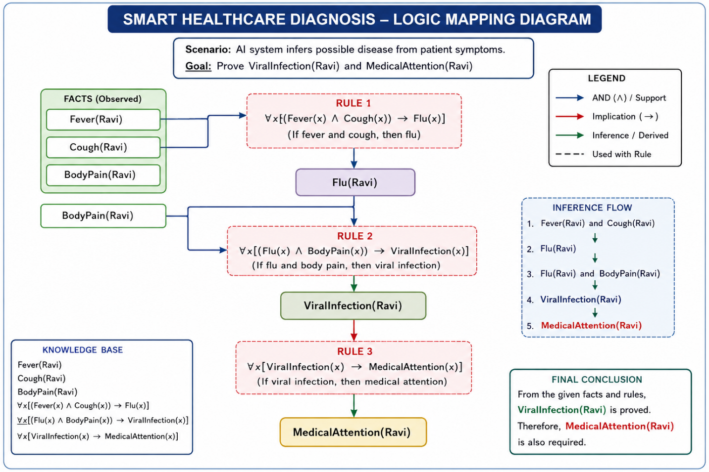

Final Answer / Conclusion
From the given facts:
Fever(Ravi),Cough(Ravi),BodyPain(Ravi)
Using the rules:
Fever(x)∧Cough(x)→Flu(x)
and
Flu(x)∧BodyPain(x)→ViralInfection(x)
we derive:
Flu(Ravi)​
and then:
ViralInfection(Ravi)​
Finally:
ViralInfection(Ravi)→MedicalAttention(Ravi)
Therefore:
Ravi has a viral infection and requires medical attention.​

